Child Enrichment Center
Enrollment Application

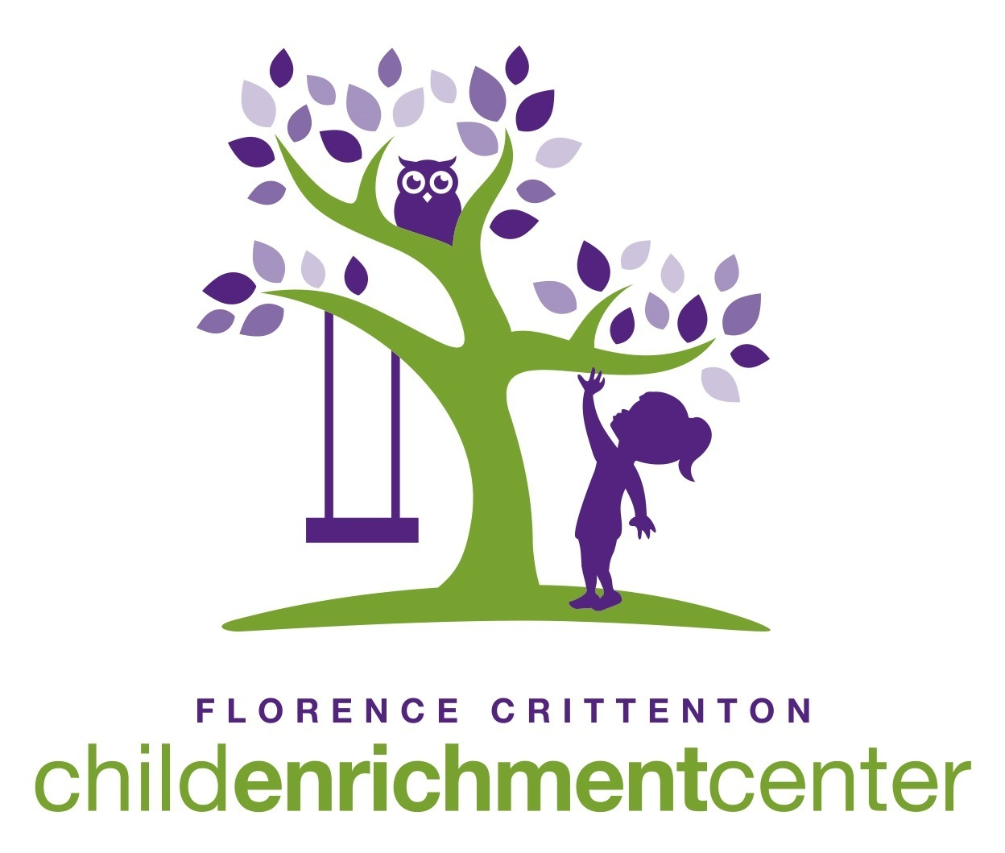
Applications may be delivered, mailed, emailed, or scanned to:
Physical and Mailing Address: Email Address:
Attn: Micaela Wilfong Recipient: Micaela Wilfong
Child Enrichment Center Email: micaelaw@florencecrittenton.org
3404 Cooney Drive Fax: 406-442-6571
Helena, MT 59602

Demographic Information
Name of Child: | Click or tap here to enter text. |  |  |  | Date of Birth: | Click or tap to enter a date.
Parent/Guardian Information
Name of Parent/Guardian: |  | Click or tap here to enter text.
Primary Phone: |  | Click or tap here to enter text.
Email Address: |  | Click or tap here to enter text.
Name of Parent/Guardian: |  | Click or tap here to enter text.
Primary Phone: |  | Click or tap here to enter text.
Email Address: |  | Click or tap here to enter text.
Parent/Guardian with whom child resides: |  |  |  | Click or tap here to enter text.
Enrollment
Type of Enrollment: |  | Choose an item.
Date for Enrollment to Begin: |  |  | Click or tap to enter a date.
Please list all the agencies that are currently serving your child:
Additional Information
How did you hear about our Child Enrichment Center?
Click or tap here to enter text.

What do you hope for your child to gain from their experience in our program?
Click or tap here to enter text.

Note: Completion of this application does not guarantee a spot in our program.

Office Use ONLY
Date Received: _____/_____/________ Date Accepted: _____/_____/________ Date Started: _____/_____/________
Payment Method(s): BBS: _____ WA-F: _____ PP: _____

